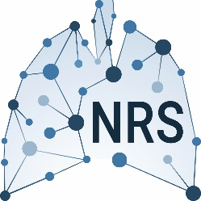
NRS Young Investigator Travel Grant
Application Form

Applicant Name:
Affiliated Institute/University:
Focus of your current research:
Are you an NRS member?
Age at the moment of applying for the travel grant:
Have you received the NRS travel grant before?
Conference you are applying for:
Date of the conference:
Location of the conference:
Is this a non-respiratory conference?
Your level of contribution at the conference affects the scoring of your application. Has your abstract been accepted for an oral, mini-oral, poster discussion or poster presentation? If so, which format?

Please make sure you have included the following documents with this form in a single PDF document:
- The abstract submitted to the conference
- A short motivation letter explaining the importance and learning objectives of the conference for the research project
- Approval letter from supervisor
- If possible, a written confirmation of an active contribution, e.g., poster or oral presentation
- A detailed budget estimate, including the contribution requested from the NRS (max € 750). Please note; Food, drinks and membership fees are not covered by the NRS Travel grant.
Your application should be sent to nrs@nrs-science.nl.

Thank you for applying for the NRS Young Investigator Travel Grant. Decisions are generally communicated 2-3 weeks after each round of submission deadlines.

